Crossed Quadrilateral
# Source: AI Source: Provided by: [Data Path: Persons Table -> ID Column: 1, Name_En Column: Motasem Essam] -> From: [ChatGPT] on [7/25/2026]
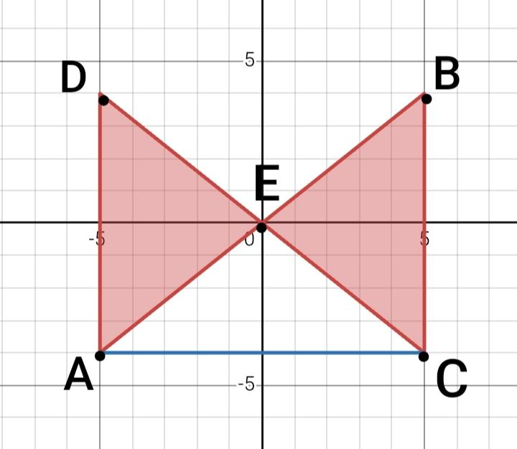
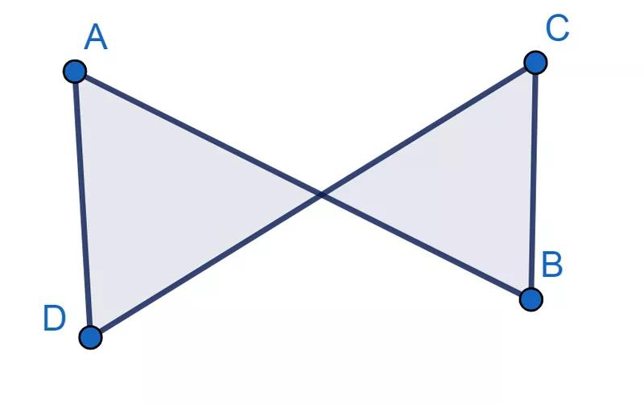
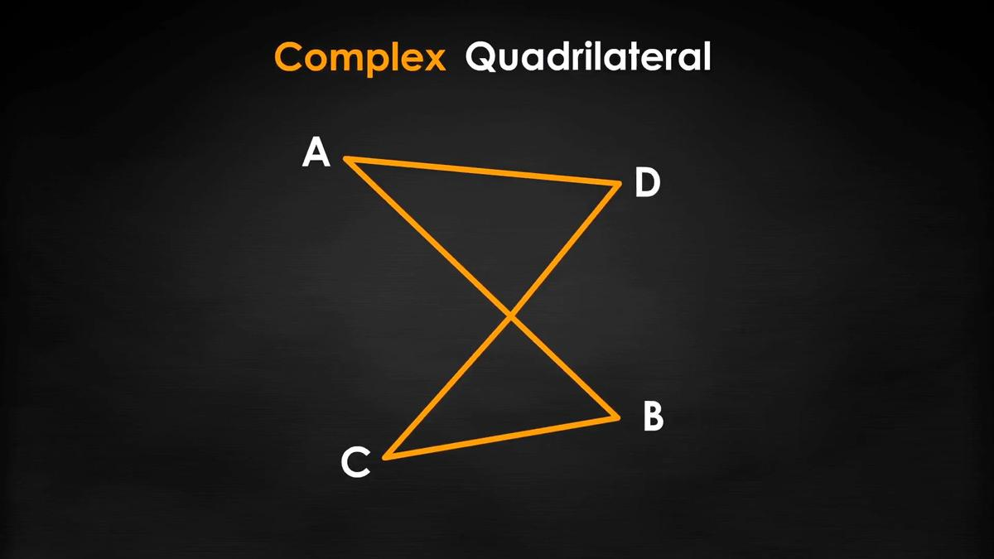
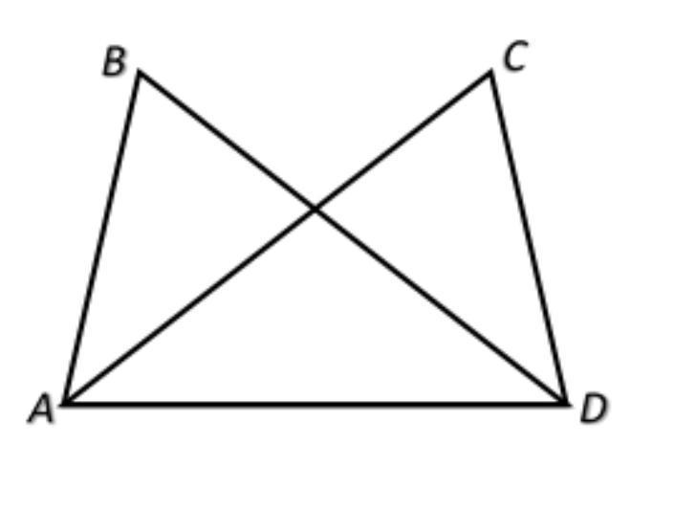

Definition
# Source: AI Source: Provided by: [Data Path: Persons Table -> ID Column: 1, Name_En Column: Motasem Essam] -> From: [ChatGPT] on [7/25/2026]
A Crossed Quadrilateral is a self-intersecting quadrilateral whose boundary consists of four line segments, with two non-adjacent sides crossing each other at a point that is not a vertex.
It is commonly called a bow-tie quadrilateral because its typical shape resembles a bow tie.
$$\boxed{\text{Crossed Quadrilateral}=\text{Self-Intersecting Quadrilateral}}$$

Fundamental Elements
# Source: AI Source: Provided by: [Data Path: Persons Table -> ID Column: 1, Name_En Column: Motasem Essam] -> From: [ChatGPT] on [7/25/2026]
A crossed quadrilateral has:
- 4 sides
- 4 vertices
- 4 boundary segments
- 1 self-intersection point in the typical configuration
- 2 pairs of non-adjacent sides
- Two or more bounded regions created by the crossing
For quadrilateral $ABCD$, its sides are:
$$AB, BC, CD, DA$$
If the sides $AB$and $CD$cross at $O$:
$$\boxed{AB∩CD=O}$$
where $O$is not a vertex.

Main Characteristic
# Source: AI Source: Provided by: [Data Path: Persons Table -> ID Column: 1, Name_En Column: Motasem Essam] -> From: [ChatGPT] on [7/25/2026]
The defining property is self-intersection.
In an ordinary quadrilateral:
$$\text{Non-adjacent sides do not intersect.}$$
In a crossed quadrilateral:
$$\boxed{\text{Non-adjacent sides intersect}}$$
This makes it different from both convex and concave simple quadrilaterals.

Shape
# Source: AI Source: Provided by: [Data Path: Persons Table -> ID Column: 1, Name_En Column: Motasem Essam] -> From: [ChatGPT] on [7/25/2026]
A typical crossed quadrilateral looks like a bow tie:
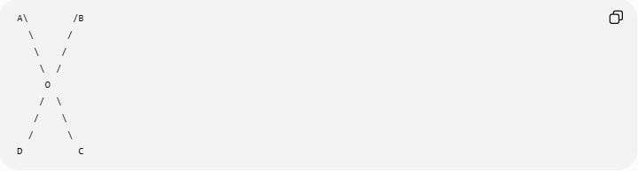
A\ /B
\ /
\ /
\ /
O
/ \
/ \
/ \
D C
The point $O$is the crossing point.

Mathematical Representation
# Source: AI Source: Provided by: [Data Path: Persons Table -> ID Column: 1, Name_En Column: Motasem Essam] -> From: [ChatGPT] on [7/25/2026]
Let the vertices be:
$$A, B, C, D$$
and connect them in the order:
$$A→B→C→D→A$$
If two non-adjacent sides intersect at $O$, then the quadrilateral is self-intersecting.
For example:
$$\boxed{AB∩CD=O}$$
or, depending on the vertex arrangement,
$$\boxed{BC∩DA=O}$$

Perimeter
# Source: AI Source: Provided by: [Data Path: Persons Table -> ID Column: 1, Name_En Column: Motasem Essam] -> From: [ChatGPT] on [7/25/2026]
The perimeter is the total length of its four sides:
$$\boxed{P=AB+BC+CD+DA}$$
The crossing point does not create an additional side.

Area
# Source: AI Source: Provided by: [Data Path: Persons Table -> ID Column: 1, Name_En Column: Motasem Essam] -> From: [ChatGPT] on [7/25/2026]
Area requires special treatment because a crossed quadrilateral does not enclose one ordinary simple interior region.
For a typical bow-tie shape, it can be divided into two triangular regions:
$$\boxed{A=A_{1}+A_{2}}$$
if the question asks for the total geometric area of the two enclosed regions.
For example, if the crossing point is $O$, the two regions can be analyzed using triangles formed around $O$.
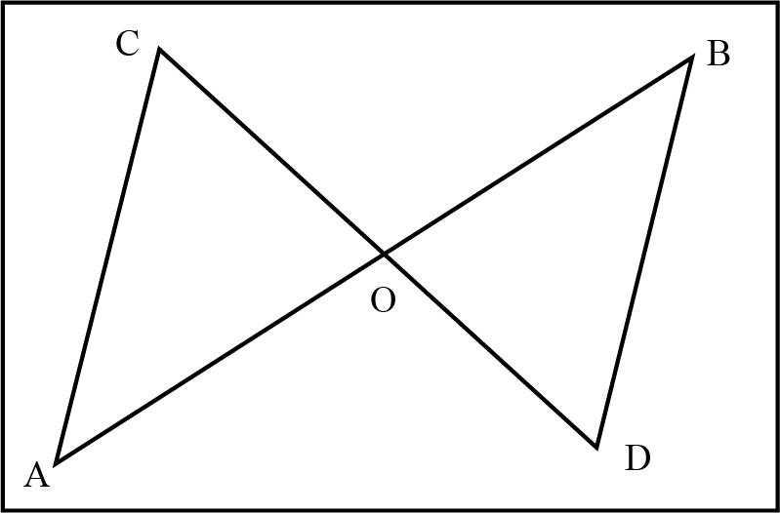
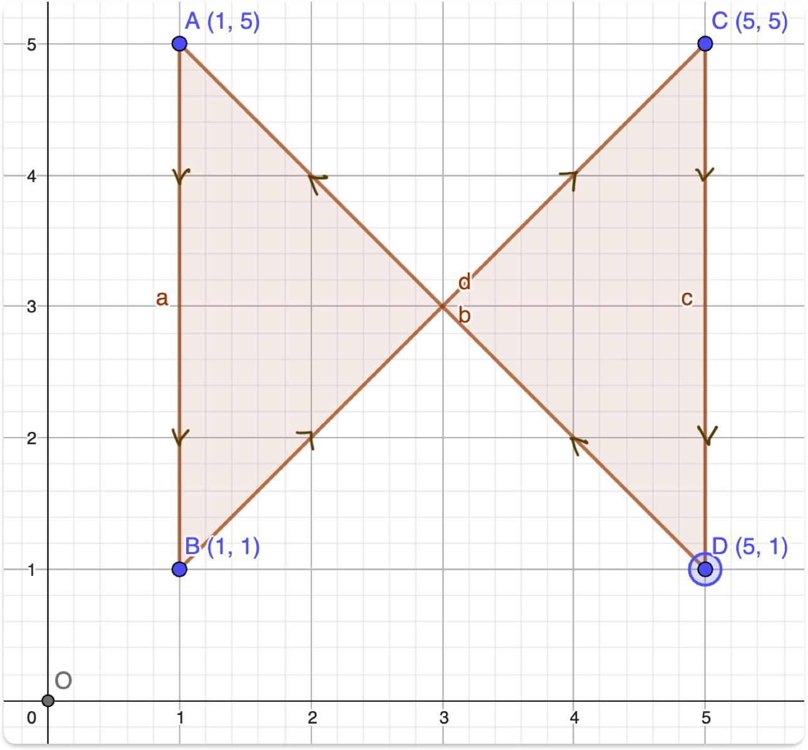
In advanced mathematics, signed area can also be used, and the result may differ because oppositely oriented regions can cancel.
Therefore, it is important to specify whether the intended measurement is geometric area or signed area.

Angles at the Crossing
# Source: AI Source: Provided by: [Data Path: Persons Table -> ID Column: 1, Name_En Column: Motasem Essam] -> From: [ChatGPT] on [7/25/2026]
The crossing point $O$creates four angles.
Because the crossing consists of two straight lines, the angles obey the standard intersecting-line relationships.
Vertical Angles
$$\boxed{∠AOC=∠BOD}$$
Linear Pairs
$$\boxed{∠AOC+∠COB={180}^{∘}}$$
These are properties of the intersecting sides at $O$.

Interior-Angle Sum
# Source: AI Source: Provided by: [Data Path: Persons Table -> ID Column: 1, Name_En Column: Motasem Essam] -> From: [ChatGPT] on [7/25/2026]
The familiar formula
$$\boxed{{360}^{∘}}$$
for the interior-angle sum of an ordinary simple quadrilateral should not be applied directly to a crossed quadrilateral.
A crossed quadrilateral is a self-intersecting polygon, so its angle structure must be treated separately.

Example
# Source: AI Source: Provided by: [Data Path: Persons Table -> ID Column: 1, Name_En Column: Motasem Essam] -> From: [ChatGPT] on [7/25/2026]
Consider the vertices:
$$A\left(0 , 0\right), B\left(4 , 4\right), C\left(0 , 4\right), D\left(4 , 0\right)$$
Connect them in this order:
$$A→B→C→D→A$$
The sides cross at:
$$O=\left(2 , 2\right)$$
Therefore:
$$\boxed{AB∩CD=O}$$
and the figure is a Crossed Quadrilateral.

Relationship with Other Quadrilaterals
# Source: AI Source: Provided by: [Data Path: Persons Table -> ID Column: 1, Name_En Column: Motasem Essam] -> From: [ChatGPT] on [7/25/2026]
A useful classification is:
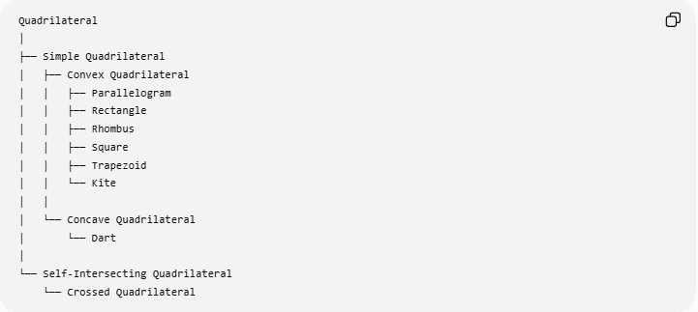
Quadrilateral
│
├── Simple Quadrilateral
│ ├── Convex Quadrilateral
│ │ ├── Parallelogram
│ │ ├── Rectangle
│ │ ├── Rhombus
│ │ ├── Square
│ │ ├── Trapezoid
│ │ └── Kite
│ │
│ └── Concave Quadrilateral
│ └── Dart
│
└── Self-Intersecting Quadrilateral
└── Crossed Quadrilateral
This is the cleanest placement for your knowledge base.

Crossed Quadrilateral vs. Dart
# Source: AI Source: Provided by: [Data Path: Persons Table -> ID Column: 1, Name_En Column: Motasem Essam] -> From: [ChatGPT] on [7/25/2026]
A Dart and a Crossed Quadrilateral should not be treated as the same type.
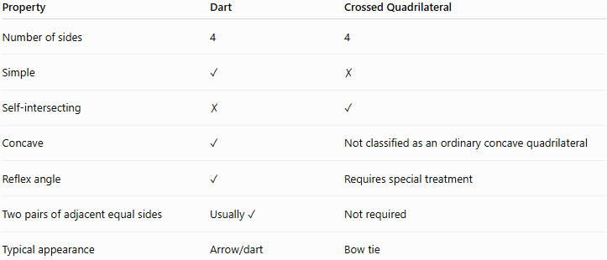
Property | Dart | Crossed Quadrilateral
Number of sides | 4 | 4
Simple | ✓ | ✗
Self-intersecting | ✗ | ✓
Concave | ✓ | Not classified as an ordinary concave quadrilateral
Reflex angle | ✓ | Requires special treatment
Two pairs of adjacent equal sides | Usually ✓ | Not required
Typical appearance | Arrow/dart | Bow tie
Thus:
$$\boxed{\text{Dart = simple concave quadrilateral}}$$
while:
$$\boxed{\text{Crossed Quadrilateral = self-intersecting quadrilateral}}$$

Relationship with Crossed Shapes
# Source: AI Source: Provided by: [Data Path: Persons Table -> ID Column: 1, Name_En Column: Motasem Essam] -> From: [ChatGPT] on [7/25/2026]
A crossed quadrilateral is a specific type of crossed shape:
$$\boxed{\text{Crossed Quadrilateral}⊂\text{Crossed Shapes}}$$
More generally:
$$\boxed{\text{Crossed Shapes}→\text{Self-Intersecting Shapes}}$$
and:
$$\boxed{\text{Crossed Quadrilateral}→\text{Self-Intersecting Quadrilateral}}$$

Real-World Applications
# Source: AI Source: Provided by: [Data Path: Persons Table -> ID Column: 1, Name_En Column: Motasem Essam] -> From: [ChatGPT] on [7/25/2026]
Crossed quadrilaterals can appear in:
- Bow-tie designs
- Logos
- Decorative patterns
- Computer graphics
- CAD models
- Geometric illustrations
- Mathematical diagrams
- Pattern design

Comparison with Other Quadrilaterals
# Source: AI Source: Provided by: [Data Path: Persons Table -> ID Column: 1, Name_En Column: Motasem Essam] -> From: [ChatGPT] on [7/25/2026]
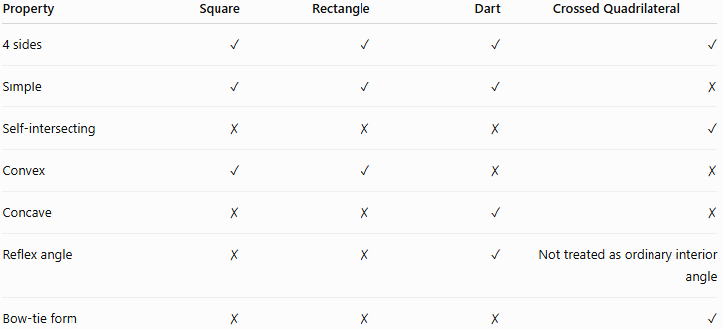
Property | Square | Rectangle | Dart | Crossed Quadrilateral
4 sides | ✓ | ✓ | ✓ | ✓
Simple | ✓ | ✓ | ✓ | ✗
Self-intersecting | ✗ | ✗ | ✗ | ✓
Convex | ✓ | ✓ | ✗ | ✗
Concave | ✗ | ✗ | ✓ | ✗
Reflex angle | ✗ | ✗ | ✓ | Not treated as ordinary interior angle
Bow-tie form | ✗ | ✗ | ✗ | ✓

Key Points
# Source: AI Source: Provided by: [Data Path: Persons Table -> ID Column: 1, Name_En Column: Motasem Essam] -> From: [ChatGPT] on [7/25/2026]
- A Crossed Quadrilateral has four sides.
- It is self-intersecting.
- Two non-adjacent sides cross at an interior point.
- It is commonly called a bow-tie quadrilateral.
- Its perimeter is:
$$\boxed{P=AB+BC+CD+DA}$$
- Its area requires special treatment.
- The usual ${360}^{∘}$interior-angle rule for simple quadrilaterals should not be applied directly.
- It belongs under Self-Intersecting Quadrilaterals, not under ordinary convex or concave quadrilaterals.

Conclusion
# Source: AI Source: Provided by: [Data Path: Persons Table -> ID Column: 1, Name_En Column: Motasem Essam] -> From: [ChatGPT] on [7/25/2026]
A Crossed Quadrilateral is the four-sided member of the Crossed Shapes category. Its defining property is that its boundary crosses itself, making it fundamentally different from simple quadrilaterals such as squares, rectangles, kites, and darts.
$$\boxed{\text{Crossed Shapes}→\text{Self-Intersecting Shapes}→\text{Crossed Quadrilateral}}$$

